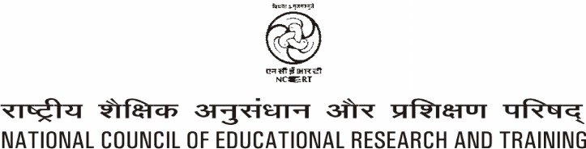

Piloting of General Education Quality
Analysis/Diagnosis Framework (GEQAF)
in India

A Report

Contents

Chapter pages

1.0 Introduction 1
2.0 General Education Quality Analysis in Madhya Pradesh and Meghalaya 4
2.1 Methodology of GEQAF Piloting 5
2.2 Major challenges to improve the quality and equity in education as
enlisted by the Piloting States 8

3.0 Suggestions for the next biennium to improve education quality 10

Annexure-I- Synthesis Report of GEQAF Tools Piloting in India 11
Annexure-II- Main points emerged from the state piloting
Meghalaya & Madhya Pradesh 17
Annexure-III- Translated GEQAF Tools-Hindi Version 30

